**AIM:**

DEVELOP APPLICATION TO DEMONSTRATE APPLICATIONS OF JQUERY

To create a simple to-do application using jQuery

**ALGORITHM**:

1. Create HTML elements for input field, add button, delete button, and a container to display tasks.
2. Optionally, style your elements for a better visual presentation.
3. Write a JavaScript function to add tasks to the container when the add button is clicked.
4. Implement a function to delete tasks when the delete button is clicked.
5. Write a function to display tasks in the container.
6. Attach event listeners to the add and delete buttons, triggering the respective functions.
7. Open your HTML file in a browser and test the functionality of adding, deleting, and displaying tasks

**index.html**

<!DOCTYPE html>

<html lang="en">

<head>

<meta charset="UTF-8" />

<meta name="viewport" content="width=device-width, initial-scale=1.0" />

<title>TASK MANAGER</title>

<link rel="stylesheet" href="./style.css" />

<script src="https://ajax.googleapis.com/ajax/libs/jquery/3.5.1/jquery.min.js"></script>

</head>

<body>

<h1>MY TO-DO TASK MANAGER</h1>

<button id="add-task-btn">ADD TASK</button>

<button id="del-task-btn">DELETE TASK</button>

<button id="show-task-btn">SHOW ALL TASKS</button>

<div id="add-container" style="display: none">

<label for="task-no">TASK NO </label>

<input type="number" name="task-no" min="1" id="task-no" /><br />

<label for="task-name">TASK-NAME </label>

<input type="text" name="task-name" id="task-name" /><br />

<label for="task-date">TASK-DATE </label>

<input type="date" name="task-date" id="task-date" /><br />

<button id="s1">Submit</button>

<input

id="cancel"

type="button"

value="Cancel"

onclick="HideContainer('add-container','add-task-btn')"

/>

</div>

<div id="del-container" style="display: none">

<label for="del-task-no">TASK NO: </label>

<input type="number" name="task-no" min="1" id="del-task-no" /><br />

<button id="d1">Delete</button>

</div>

<div id="show-container" style="display: none">

<h4 id="tasks-to-do" style="display: none">TASKS TO DO</h4>

<p id="show-tasks"></p>

<button

id="close"

onclick="HideContainer('show-container','show-task-btn')"

>

Close

</button>

</div>

</body>

<script src="./script1.js"></script>

</html>

**script.js**

const inputArray = [];

//add task functions

$("#add-task-btn").click(function() {

ViewContainer("add-container", "add-task-btn");

HideContainer("show-container", "show-task-btn");

HideContainer("del-container", "del-task-btn");

});

$("#s1").click(function() {

const taskno = $("#task-no").val();

const taskname = $("#task-name").val();

const taskdate = $("#task-date").val();

const object1 = {

TaskNo: taskno,

TaskName: taskname,

TaskDate: taskdate,

};

inputArray.push(object1);

alert("YOUR TASK -" + taskname + "- DATED -" + taskdate + "- WAS CREATED");

HideContainer("add-container", "add-task-btn");

$("#task-no").val("");

$("#task-name").val("");

$("#task-date").val("");

});

// Displaying the tasks in table format

$("#show-task-btn").click(function() {

ViewContainer("show-container", "show-task-btn");

HideContainer("add-container", "add-task-btn");

HideContainer("del-container", "del-task-btn");

$("#tasks-to-do").show();

const showTasks = $("#show-tasks");

showTasks.empty();

for (let i = 0; i < inputArray.length; i++) {

showTasks.append(

"<table border='1'><tr><td>" +

inputArray[i].TaskNo +

"</td><td>" +

inputArray[i].TaskName +

"</td><td>" +

inputArray[i].TaskDate +

"</td></tr></table>"

);

}

});

//Delete task Button

$("#del-task-btn").click(function() {

ViewContainer("del-container", "del-task-btn");

HideContainer("show-container", "show-task-btn");

HideContainer("add-container", "add-task-btn");

});

$("#d1").click(function() {

const delTaskNo = $("#del-task-no").val();

for (let i = 0; i < inputArray.length; i++) {

if (inputArray[i].TaskNo == delTaskNo) {

inputArray.splice(i, 1);

alert("TASK NO " + delTaskNo + " WAS DELETED");

break;

}

}

HideContainer("del-container", "del-task-btn");

$("#del-task-no").val("");

});

function HideContainer(boxid, btnid) {

const box = $("#" + boxid);

const btn = $("#" + btnid);

box.hide();

btn.css("background-color", "");

btn.css("color", "");

}

function ViewContainer(boxid, btnid) {

const box = $("#" + boxid);

const btn = $("#" + btnid);

box.show();

btn.css("background-color", "green");

btn.css("color", "white");

}

**TO-DO APPLICATION SCREEN SHOT**

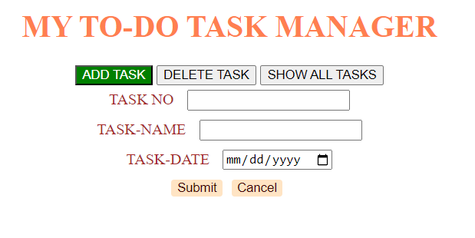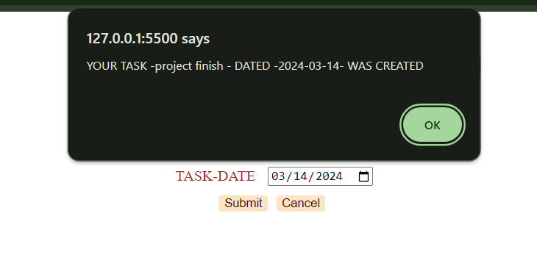

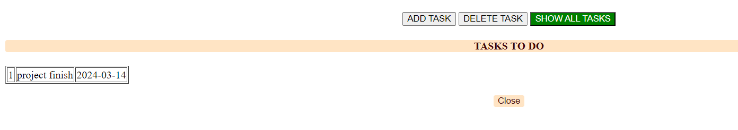

**RESULT:** Thus, we have successfully created a to-do application using HTML5 and jQuery